CSC496 – Data Warehousing and Data Mining
Name: Aoun Haider
ID: FA21-BSE-133
Submitted to: Mr. Usman Shahzaib
CLO:<03>; Apply ETL process on small to medium size designed data warehouse. Bloom Taxonomy Level: <Applying>
Question 1:
Design ETL pipeline in continuation of assignment 2.
Table 1
Table 2
ADO .NET source
Data Source
Conditional Split on profit and quantity
Group by sales person id

Data Source: ADO. NET
Target Database: WorldWideImporters (NorthwindDB)
Target Fact table: Sales
Analysis: Find salesperson who has made high profit with high quantity of sales, low profit with low quantity of sales, high profit with low quantity of sale and low profit with high quantity of sale.

Proposed ETL pipeline implementation:
Loading: Connect with ADO.NET data source with sales fact table.
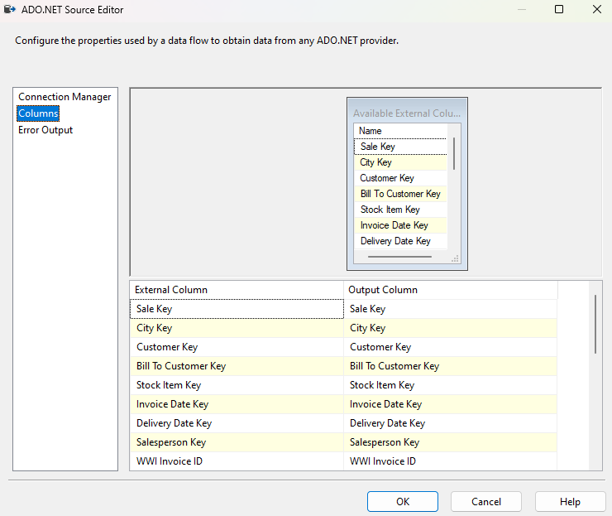

Transformation: Aggregate transformation to group sales person by Sales Person Key and find average profit and sum the quantity.
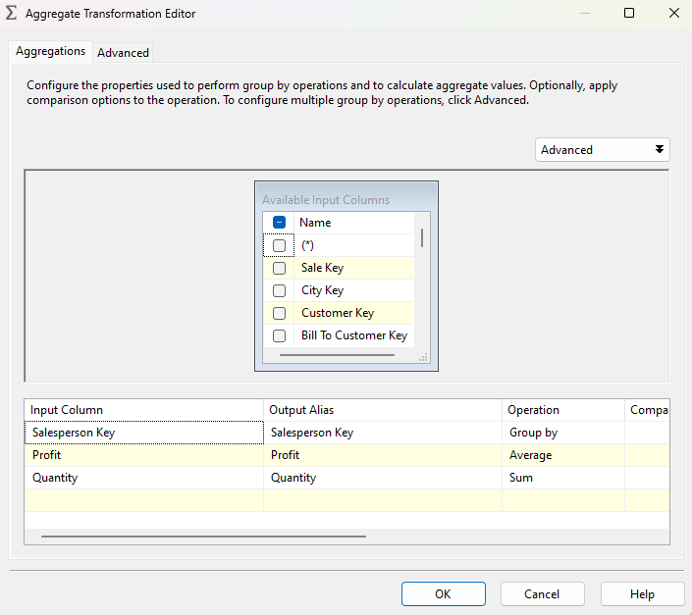

Split based on profit and quantity using Conditional Split component:
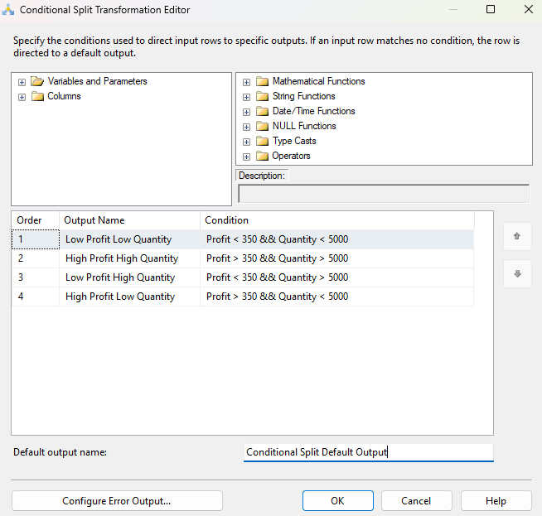

Create destination table with ADO.NET destination. Also create source to target mapping.
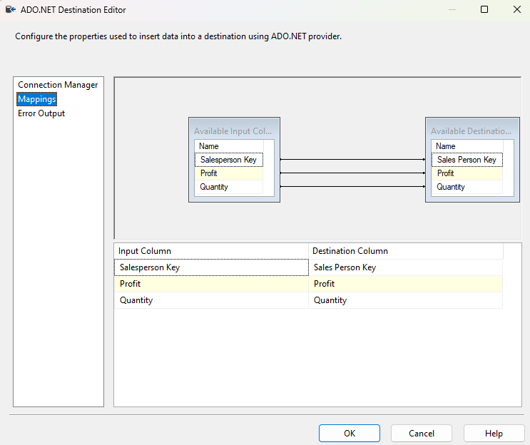

Create a final end-to-end pipeline:
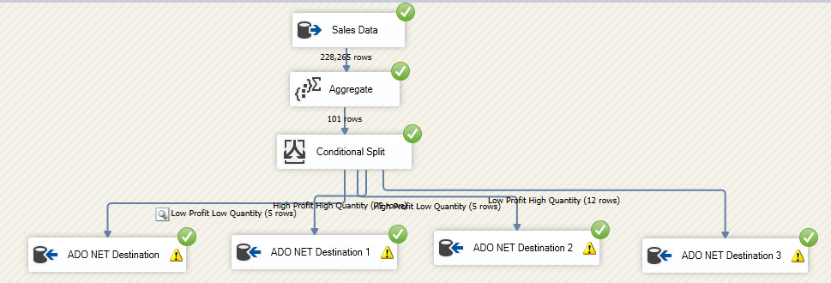
Checking database for created tables:
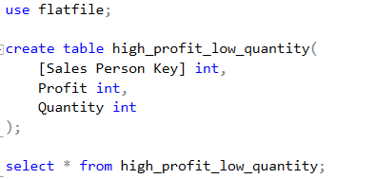
Database table created:
